Villagers meeting held on Oran
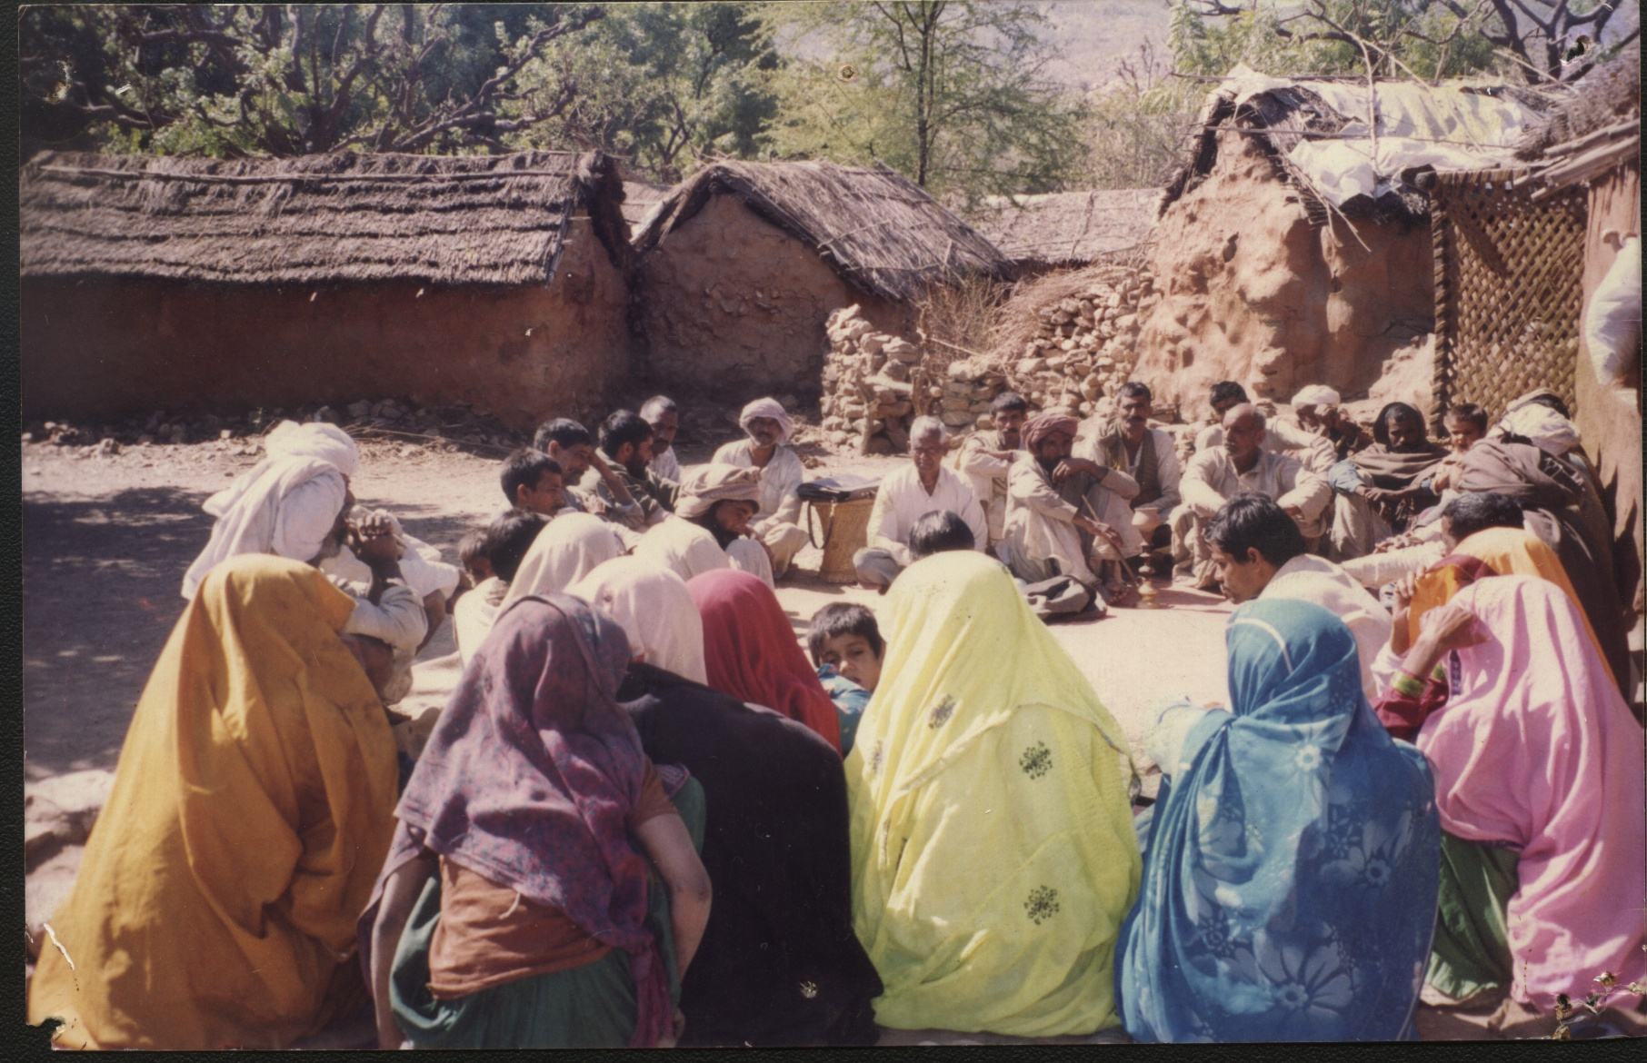
Conservation in Bera village

